Q1. **Implement a menu driven Program in C++ using function for the following Array operations**

**a. Creating an Array of N Integer Elements**

**b. Display of Array Elements**

**c. Display sum of array elements.**

**d. Deleting an Element at a given valid Position(POS)**

#include<iostream>

using namespace std;

int main()

{

int arr[30],i,size,sum=0,choice,ele,flag=0;

char ch,status;

cout<<"Enter the size of the array: \n";

cin>>size;

cout<<"Enter the elements of the array: \n";

for(i=0;i<size;i++)

cin>>arr[i];

cout<<"*******MENU*******\n";

cout<<"1.Display the array elements\n";

cout<<"2.Display sum of the array elements\n";

cout<<"3.Delete an element from the array\n";

cout<<"Enter your choice:\n";

cin>>choice;

switch(choice)

{

case 1:

cout<<"Array is: ";

for(i=0;i<size;i++)

cout<<arr[i];

cout<<"\n";

break;

case 2:

for(i=0;i<size;i++)

sum+=arr[i];

cout<<"The sum of the array elements is: "<<sum;

cout<<"\n";

break;

case 3:

cout<<"Enter the element you want to delete: \n";

cin>>ele;

for(i=0;i<size;i++)

{

if(arr[i]==ele)

{

while(i<size)

{

flag==1;

arr[i]=arr[i+1];

i++;

}

break;

}

}

if(flag=0)

cout<<"\nNo such element present..";

cout<<"\nArray is: ";

for(i=0;i<size-1;i++)

cout<<arr[i];

cout<<"\n";

break;

default: cout<<"\nInvalid choice....\n";

}

}

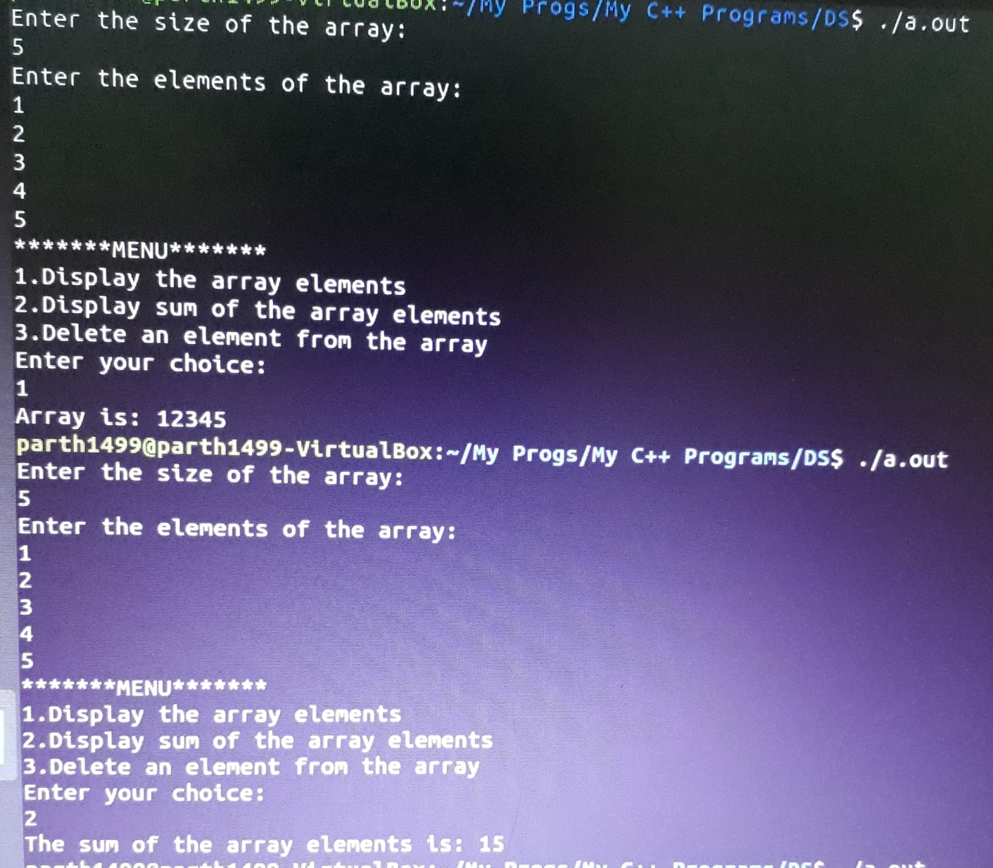

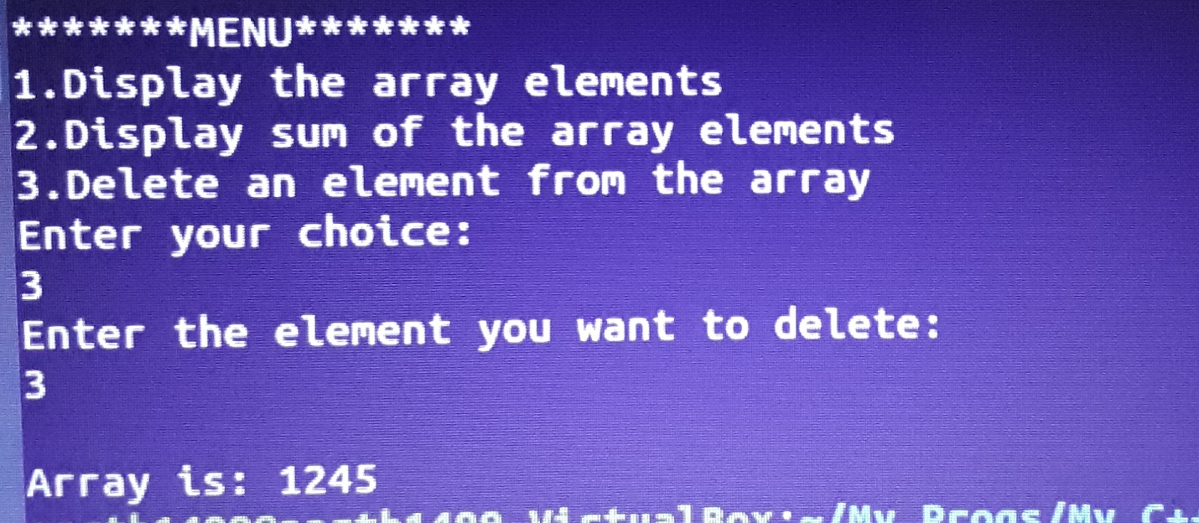

Q2 Implement following operations on string with pointers (without using library functions)

i. Length

ii. Palindrome

iii. String comparison

#include <iostream>

using namespace std;

int palindrome(char *a)

{

int i,len=0;

char temp;

while(a[len]!='\0')

len++;

for(i=0;i<(len/2);i++)

{

if(a[i]!=a[(len-1)-i])

return 0;

}

return 1;

}

int length(char *a)

{

int len=0;

while(a[len]!='\0')

len++;

return len;

}

int compare(char *a, char *b)

{

int i;

while(*a!='\0'||*b!='\0')

{

if(*a!=*b)

{

return *a-*b;

}

a++,b++;

}

return 0;

}

int main()

{

int choice,flag;

char str1[50],str2[50],again;

do

{

cout<<"\n*****MENU*****\n";

cout<<"Press 1 for String Length.\n";

cout<<"Press 2 for String comparision.\n";

cout<<"Press 3 for Palindrome.\n";

cout<<"Press 4 for EXIT.\n";

cout<<"Enter your choice: ";

cin>>choice;

switch(choice)

{

case 1:

cout<<"\nEnter 1st String: ";

cin>>str1;

flag=length(str1);

cout<<"Length of "<<str1<<" = "<<flag;

break;

case 2:

cout<<"Enter the 1st String: ";

cin>>str1;

cout<<"Enter the 2nd String: ";

cin>>str2;

flag=compare(str1,str2);

if(flag>0)

cout<<"\nString 1("<<str1<<") is greater than String 2("<<str2<<").\n";

else if(flag<0)

cout<<"\nString 2("<<str2<<") is greater than String 1("<<str1<<").\n";

else

cout<<"\nString 1("<<str1<<") is equal to String 2("<<str2<<").\n";

break;

case 3:

cout<<"\nEnter the String: ";

cin>>str2;

flag=palindrome(str2);

if(flag==1)

cout<<"\nEntered String ("<<str1<<") is a Palindrome.\n";

else

cout<<"\nEntered String ("<<str1<<") is not a Palindrome.\n";

break;

case 4:

exit(1);

break;

default:

cout<<"\nERROR: Invalid Entry.....Try again.\n";

}

cout<<"\nTo run the program again, press y/Y else press n/N: ";

cin>>again;

}while((again=='y')||(again=='Y'));

}

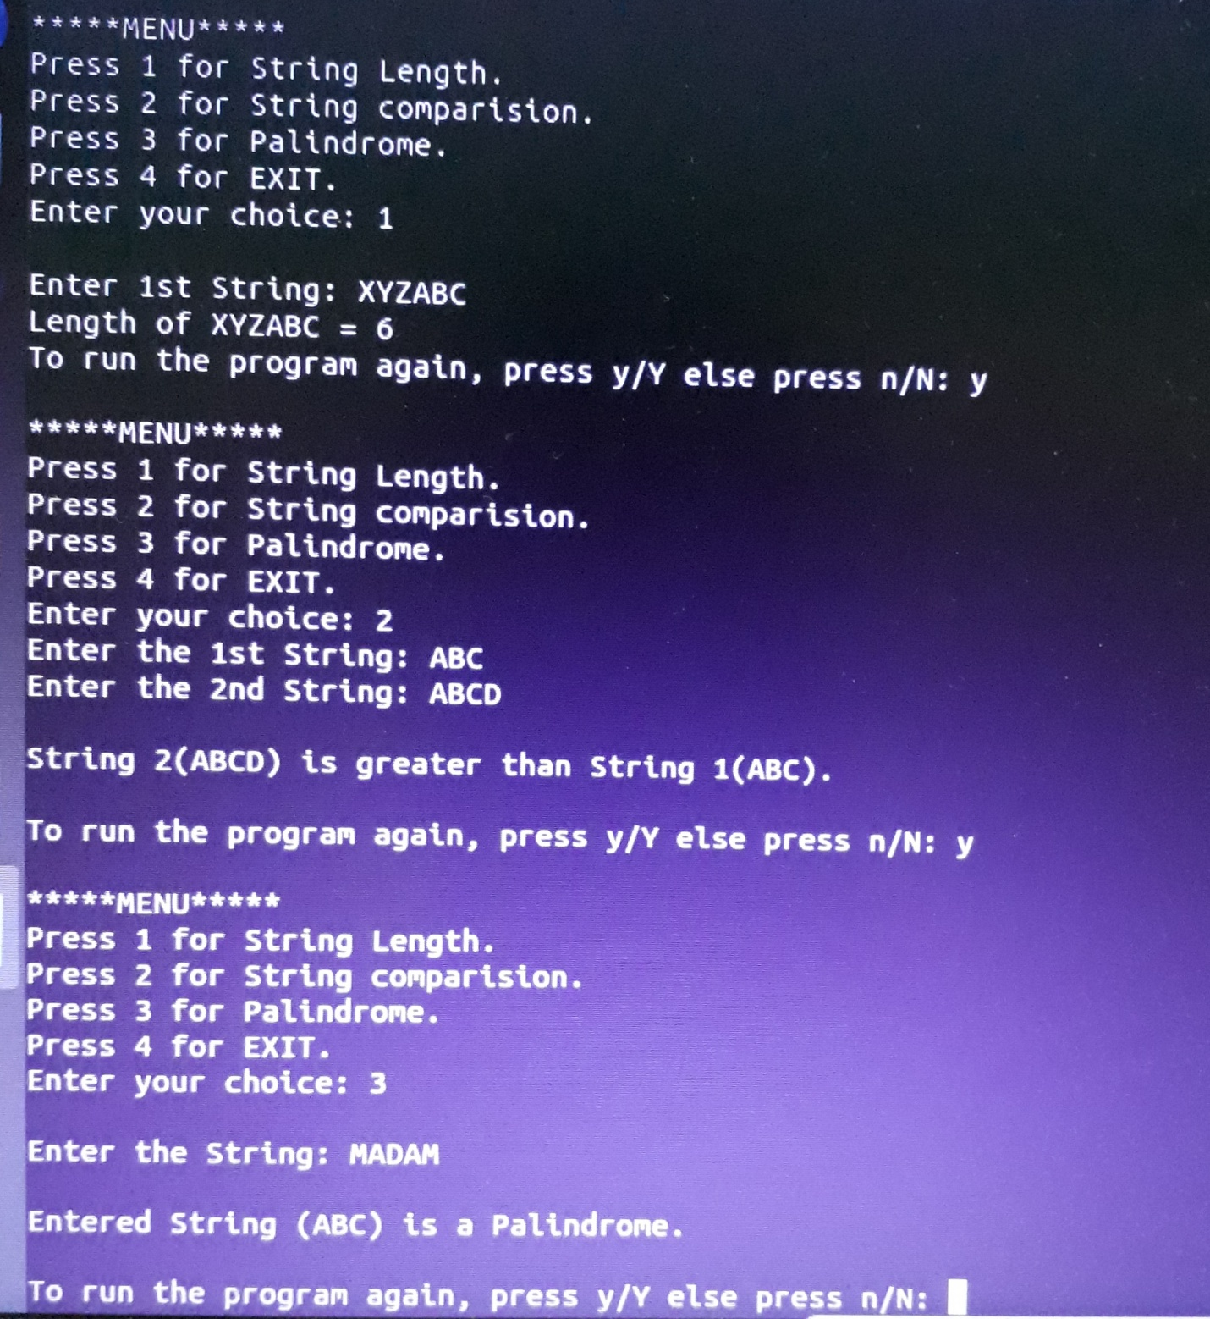

Q3 Implement following operations on string with pointers (without using library functions)

i. Copy

ii. Reverse

iii. Substring

#include <iostream>

using namespace std;

void copy(char *a,char *b)

{

while(*b!='\0')

{

*a=*b;

a++;

b++;

}

*a='\0';

}

void reverse(char *a)

{

int i,len=0;

char temp;

while(a[len]!='\0')

len++;

for(i=0;i<(len/2);i++)

{

temp=a[i];

a[i]=a[(len-1)-i];

a[(len-1)-i]=temp;

}

}

int substring(char *a,char *sub)

{

int i,s=0,flag=0,len=0,lenSub=0;

while(a[len]!='\0')

len++;

while(sub[lenSub]!='\0')

lenSub++;

for(i=0;i<=len;i++)

{

if(a[i]==sub[s])

{

s++;

if(sub[s]=='\0')

{

flag=1;

break;

}

}

else

{

s=0;

flag=0;

}

}

return flag;

}

int main()

{

int choice,flag;

char str1[50],str2[50],again;

do

{

cout<<"\n*****MENU*****\n";

cout<<"Press 1 for copying one string to another.\n";

cout<<"Press 2 for String reverse.\n";

cout<<"Press 3 for finding substring.\n";

cout<<"Press 4 for EXIT.\n";

cout<<"Enter your choice: ";

cin>>choice;

switch(choice)

{

case 1:

cout<<"\nEnter 1st String: ";

cin>>str1;

cout<<"Enter 2nd string: ";

cin>>str2;

cout<<"\nString 1: "<<str1;

cout<<"\nString 2: "<<str2;

copy(str2,str1);

cout<<"\nString copied.....";

cout<<"\nString 1: "<<str1;

cout<<"\nString 2: "<<str2<<"\n";

break;

case 2:

cout<<"\nEnter the String: ";

cin>>str1;

reverse(str1);

cout<<"\nString reversed...\n";

cout<<"Reversed String: "<<str1<<"\n";

break;

case 3:

cout<<"\nEnter the string: ";

cin>>str1;

cout<<"Enter 2nd string: ";

cin>>str2;

flag= substring(str1,str2);

if(flag==1)

cout<<"\nSEARCH SUCCESSFUL....\n"<<str2<<" is the substring of "<<str1<<".\n";

else

cout<<"\nSEARCH UNSUCCESSFUL....\n"<<str2<<" is not the substring of "<<str1<<".\n";

break;

case 4:

exit(1);

break;

default:

cout<<"\nERROR: Invalid Entry.....Try again.\n";

}

cout<<"\nTo run the program again, press y/Y else press n/N: ";

cin>>again;

}while((again=='y')||(again=='Y'));

}

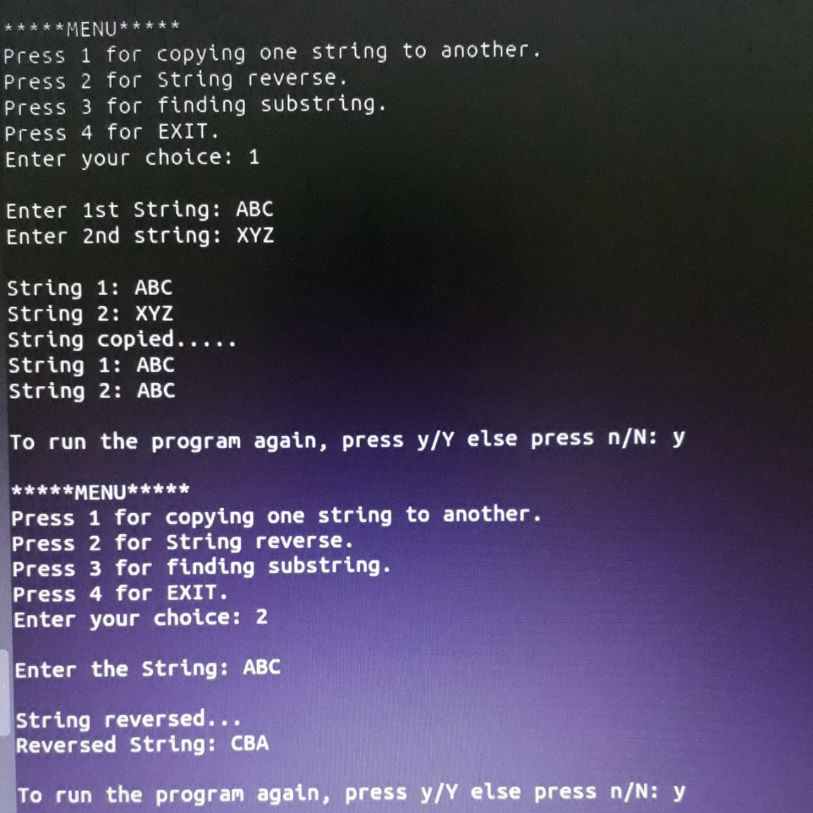

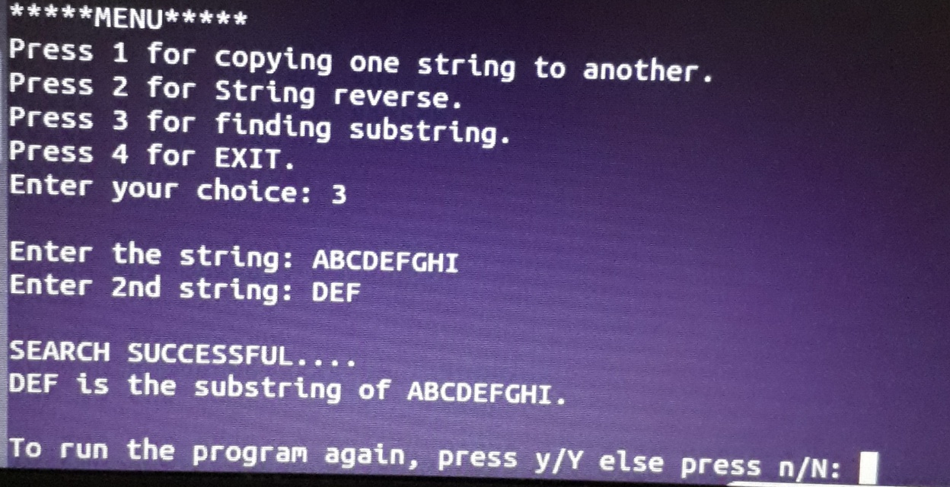

Q4 Implement a menu driven Program in C++ for the following operations on Doubly Linked List

(DLL) of Employee Data with the fields: EMP-ID, Name, Dept, Designation,PhNo.

a.Create a DLL of N Employees Data.

b. Display the DLL

c.Perform Insertion

#include<iostream>

using namespace std;

typedef struct emp

{

long int id,no;

char name[50],dept[50],des[50];

struct emp *next;

struct emp *pre;

}node;

node *first=NULL;

node *accept()

{

node *a;

a=new node;

cout<<"Enter id: ";

cin>>a->id;

cout<<"Enter name: ";

cin>>a->name;

cout<<"Enter the department: ";

cin>>a->dept;

cout<<"Enter designation: ";

cin>>a->des;

cout<<"Enter contact number: ";

cin>>a->no;

a->next=NULL;

a->pre==NULL;

return(a);

}

node *create(node *first)

{

char p;

do

{

node *a,*newnode;

newnode=accept();

if(first==NULL)

{

first=newnode;

}

else

{

a=first;

while(a->next!=NULL)

a=a->next;

a->next=newnode;

newnode->pre=a;

}

cout<<"Do you wish to create another one?\n";

cin>>p;

}while(p=='y'||p=='Y');

return(first);

}

void display(node *first)

{

if(first==NULL)

{

cout<<"No list exists\n";

}

else

{

node *a;

a=first;

cout<<"_______________________________________________________________________\n";

cout<<"ID\tName\tDepartment\tDesignation\tContact\n";

while(a!=NULL)

{

cout<<a->id<<"\t"<<a->name<<"\t\t"<<a->dept<<"\t\t"<<a->des<<"\t"<<a->no<<"\n";

a=a->next;

}

}

}

node *ins_beg(node *first)

{

node *newnode;

newnode=accept();

newnode->next=first;

newnode->pre=NULL;

first->pre=newnode;

return newnode;

}

node *ins_end(node *first)

{

node *newnode;

node *a=first;

newnode=accept();

while(a->next!=NULL)

{

a=a->next;

}

a->next=newnode;

newnode->pre=a;

return a;

}

node *ins_pos(node *first)

{

node *newnode;

node *a=first;

newnode=accept();

int eid;

cout<<"Enter empid after which you wish to add?\n";

cin>>eid;

while(a->id!=eid && a->next!= NULL)

{

a=a->next;

}

if(a->next==NULL)

{

cout<<"Underflow\n";

}

else

{

newnode->next=a->next;

newnode->pre=a;

(a->next)->pre=newnode;

a->next=newnode;

}

return a;

}

int main()

{

char op;

do

{

long int c;

node *a;

cout<<"What do you wish to do? \n1] Create \n2] Display \n3] Insert at start \n";

cout<<"4] Insert at end \n5] Insert at position\n";

cin>>c;

switch(c)

{

case 1: first=create(first);

break;

case 2: display(first);

break;

case 3: first=ins_beg(first);

break;

case 4: a=ins_end(first);

break;

case 5: a=ins_pos(first);

break;

default:cout<<"Invalid\n";

}

cout<<"Do you wish to continue?\n";

cin>>op;

}while(op=='y'||op=='Y');

return 0;

}

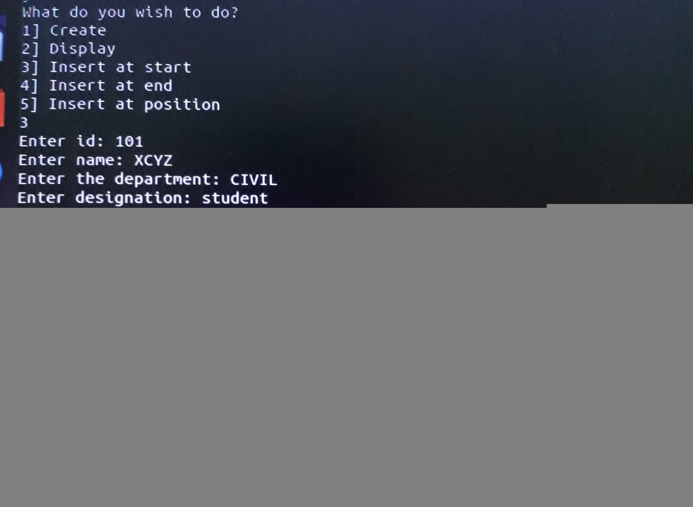

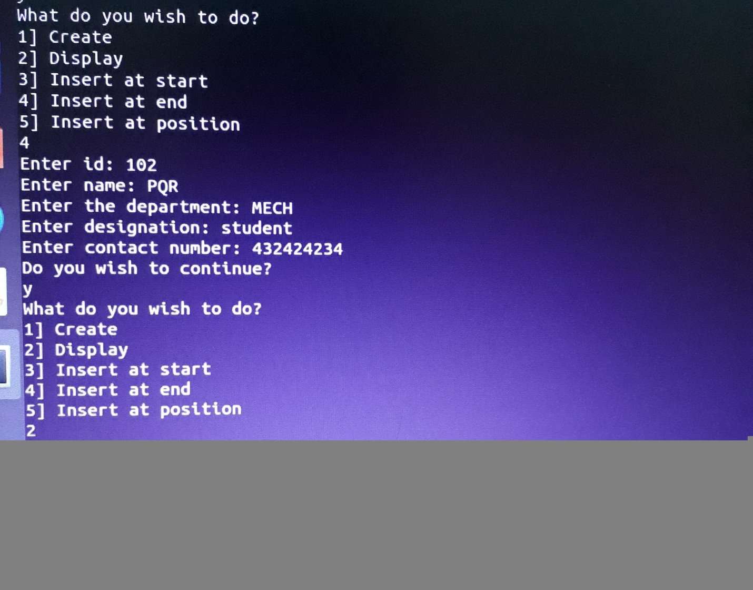

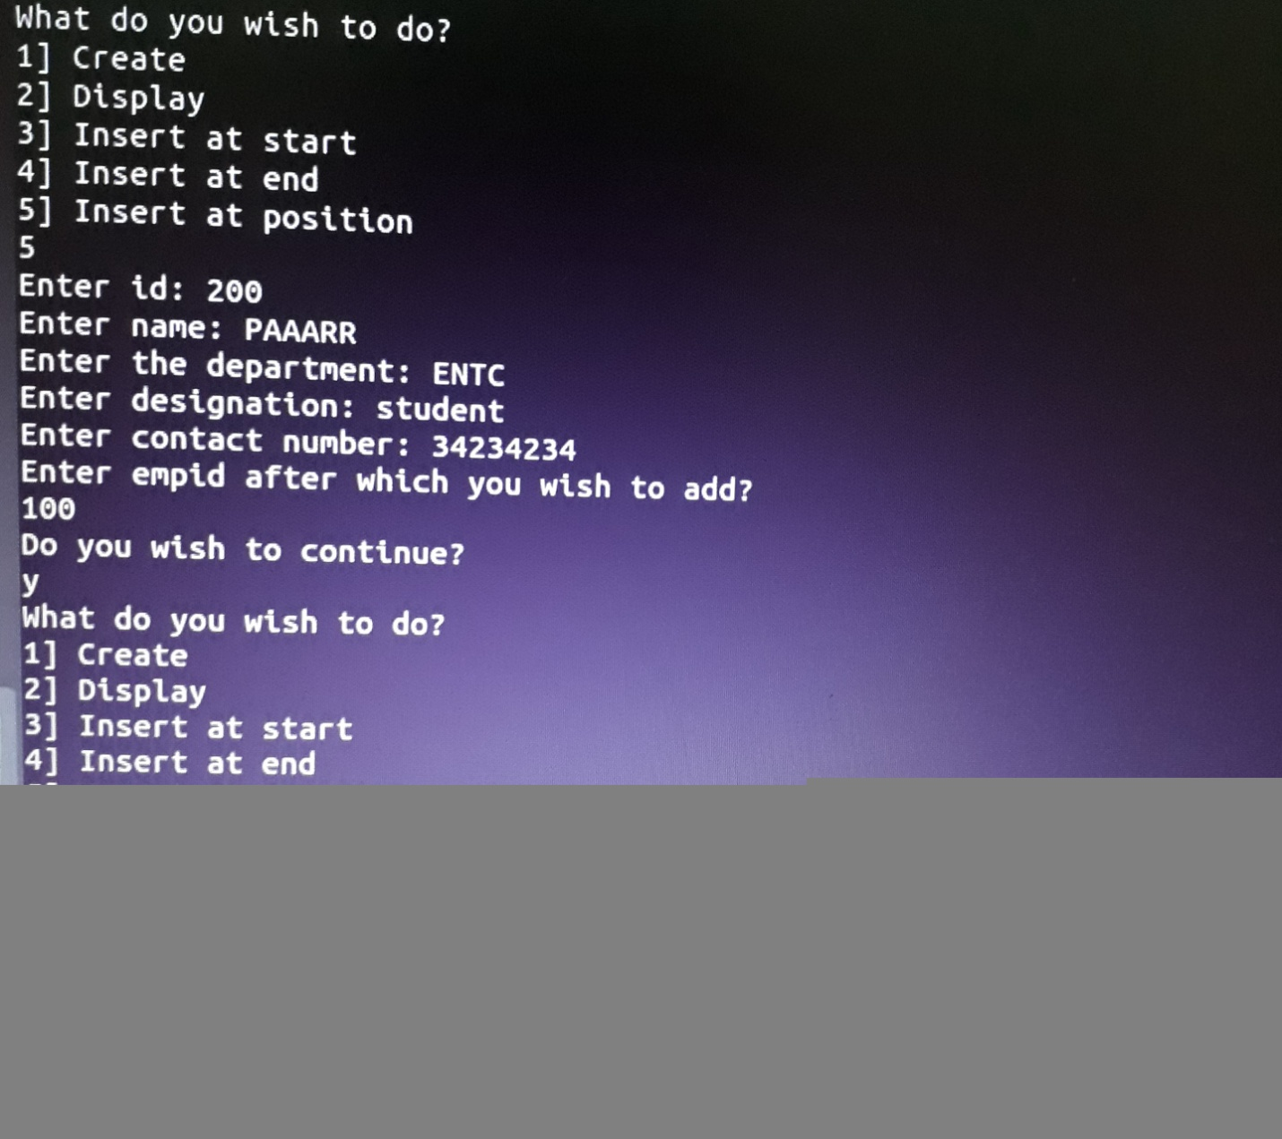

Q5 Implement a menu driven Program in C++ for the following operations on Doubly Linked List

(DLL) of Employee Data with the fields: EMP-ID, Name, Dept, Designation,PhNo.

a.Create a DLL of N Employees Data.

b.Perform Deletion

c. Display the DLL

#include<iostream>

using namespace std;

typedef struct emp

{

long int id,no;

char name[50],dept[50],des[50];

struct emp *next;

struct emp *pre;

}node;

node *first=NULL;

node *accept()

{

node *a;

a=new node;

cout<<"Enter id: ";

cin>>a->id;

cout<<"Enter name: ";

cin>>a->name;

cout<<"Enter the department: ";

cin>>a->dept;

cout<<"Enter designation: ";

cin>>a->des;

cout<<"Enter contact number: ";

cin>>a->no;

a->next=NULL;

a->pre==NULL;

return(a);

}

node *create(node *first)

{

char p;

do

{

node *a,*b,*newnode;

newnode=accept();

if(first==NULL)

{

first=newnode;

}

else

{

a=first;

while(a->next!=NULL)

a=a->next;

a->next=newnode;

newnode->pre=a;

}

cout<<"Do you wish to create another one?\n";

cin>>p;

}while(p=='y'||p=='Y');

return(first);

}

void display(node *first)

{

if(first==NULL)

{

cout<<"No list exists\n";

}

else

{

node *a;

a=first;

cout<<"_______________________________________________________________________\n";

cout<<"ID\tName\tDepartment\tDesignation\tContact\n";

while(a!=NULL)

{

cout<<a->id<<"\t"<<a->name<<"\t\t"<<a->dept<<"\t\t"<<a->des<<"\t"<<a->no<<"\n";

a=a->next;

}

}

}

node *del_beg(node *first)

{

node *temp=first;

first=first->next;

temp->next=NULL;

first->pre=NULL;

delete temp;

return first;

}

void del_end(node *first)

{

node *a=first;

while(a->next!=NULL)

{

a=a->next;

}

node *b;

b=a->pre;

b->next=NULL;

a->pre=NULL;

delete a;

}

void del_pos(node *first)

{

node *temp=first;

temp=temp->next;

node *a=first;

int eid;

cout<<"Enter the employee id you wish to delete\n";

cin>>eid;

while(temp->id!=eid)

{

temp=temp->next;

a=a->next;

}

a->next=temp->next;

(temp->next)->pre=a;

delete temp;

}

int main()

{

char op;

do

{

long int c;

node *a;

cout<<"What do you wish to do?\n1] Create\n2] Display\n";

cout<<"3] Delete from start\n4] Delete from end\n5] Delelte from position\n";

cin>>c;

switch(c)

{

case 1: first=create(first);

break;

case 2: display(first);

break;

case 3: first=del_beg(first);

break;

case 4: del_end(first);

break;

case 5: del_pos(first);

break;

default:cout<<"Invalid\n";

}

cout<<"Do you wish to continue?\n";

cin>>op;

}while(op=='y'||op=='Y');

return 0;

}

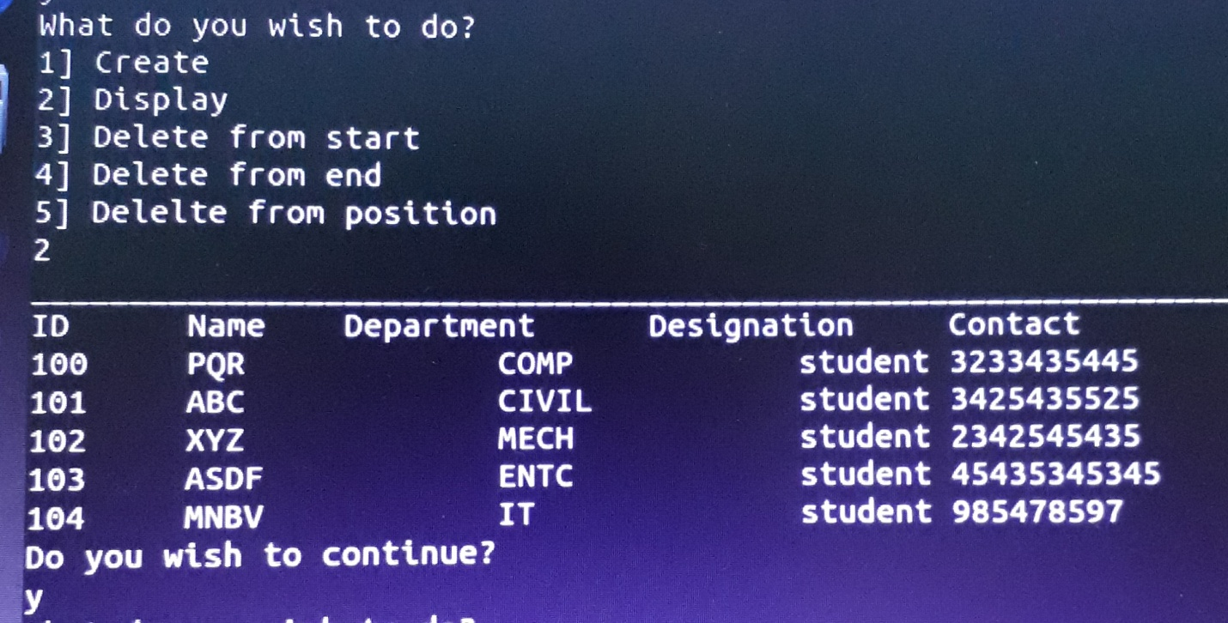

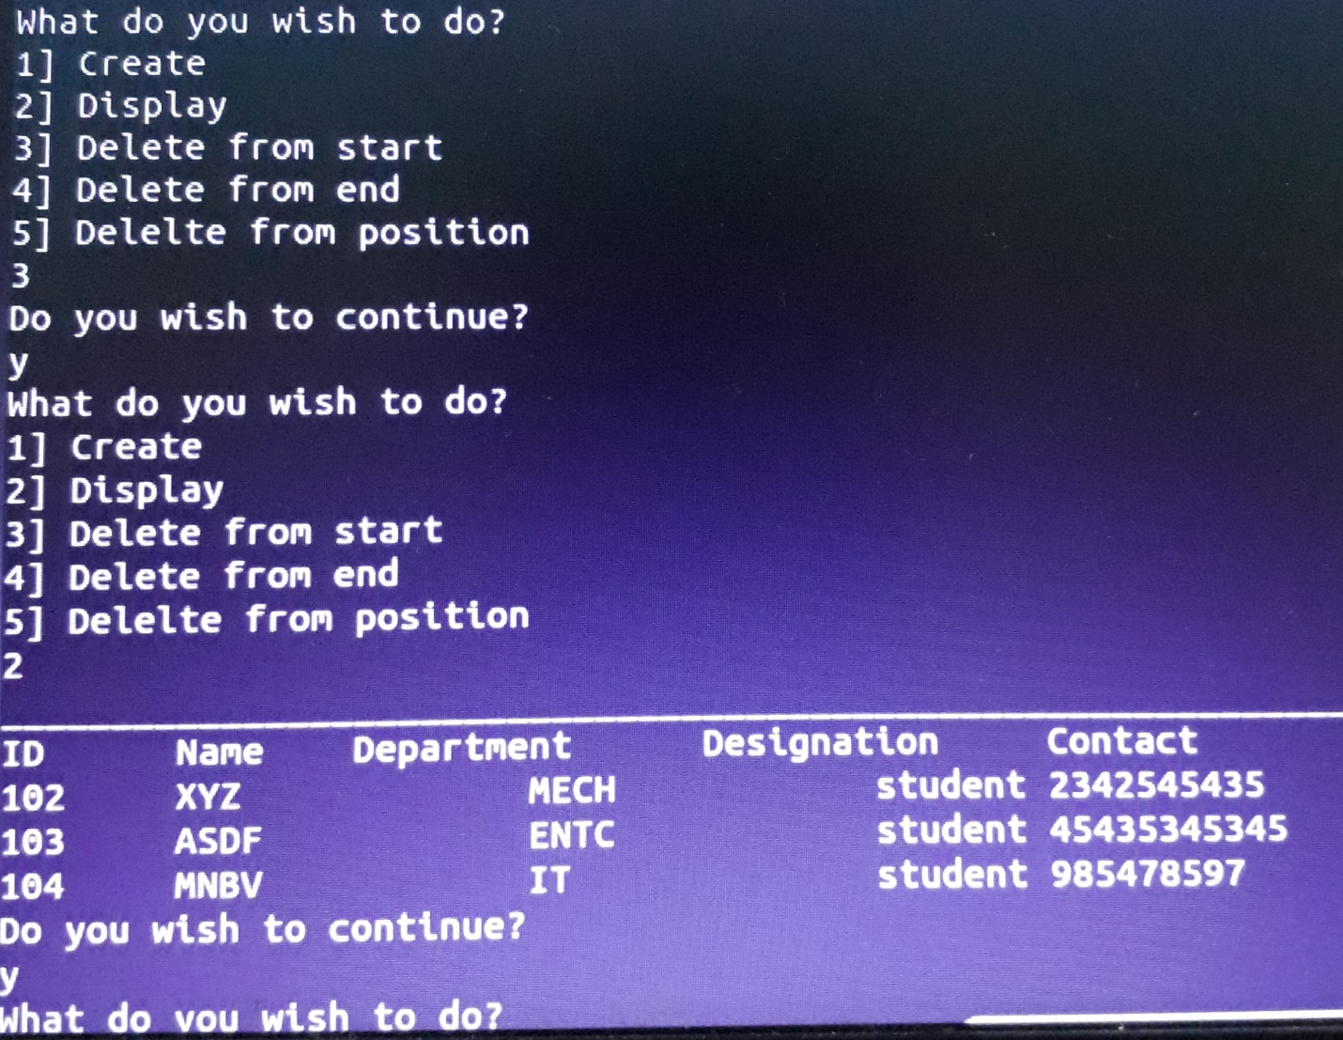

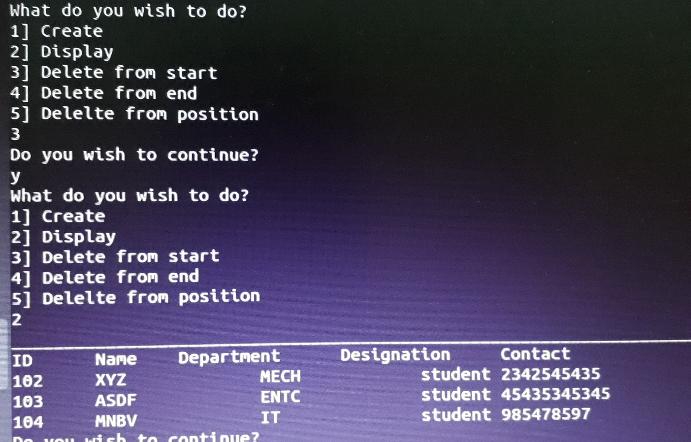

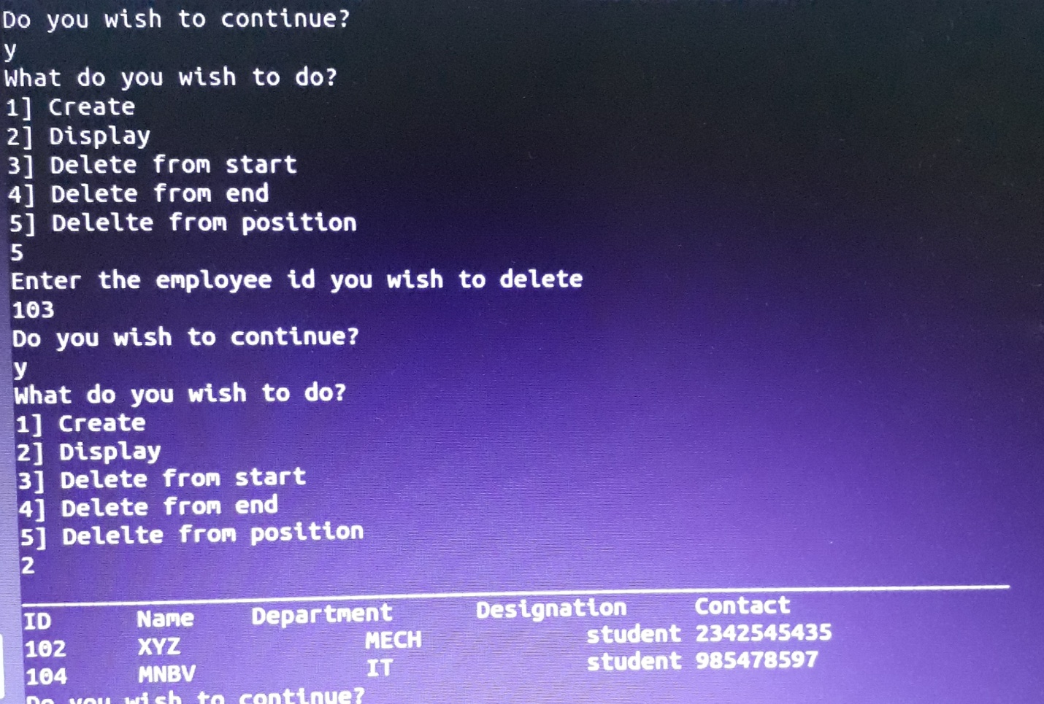

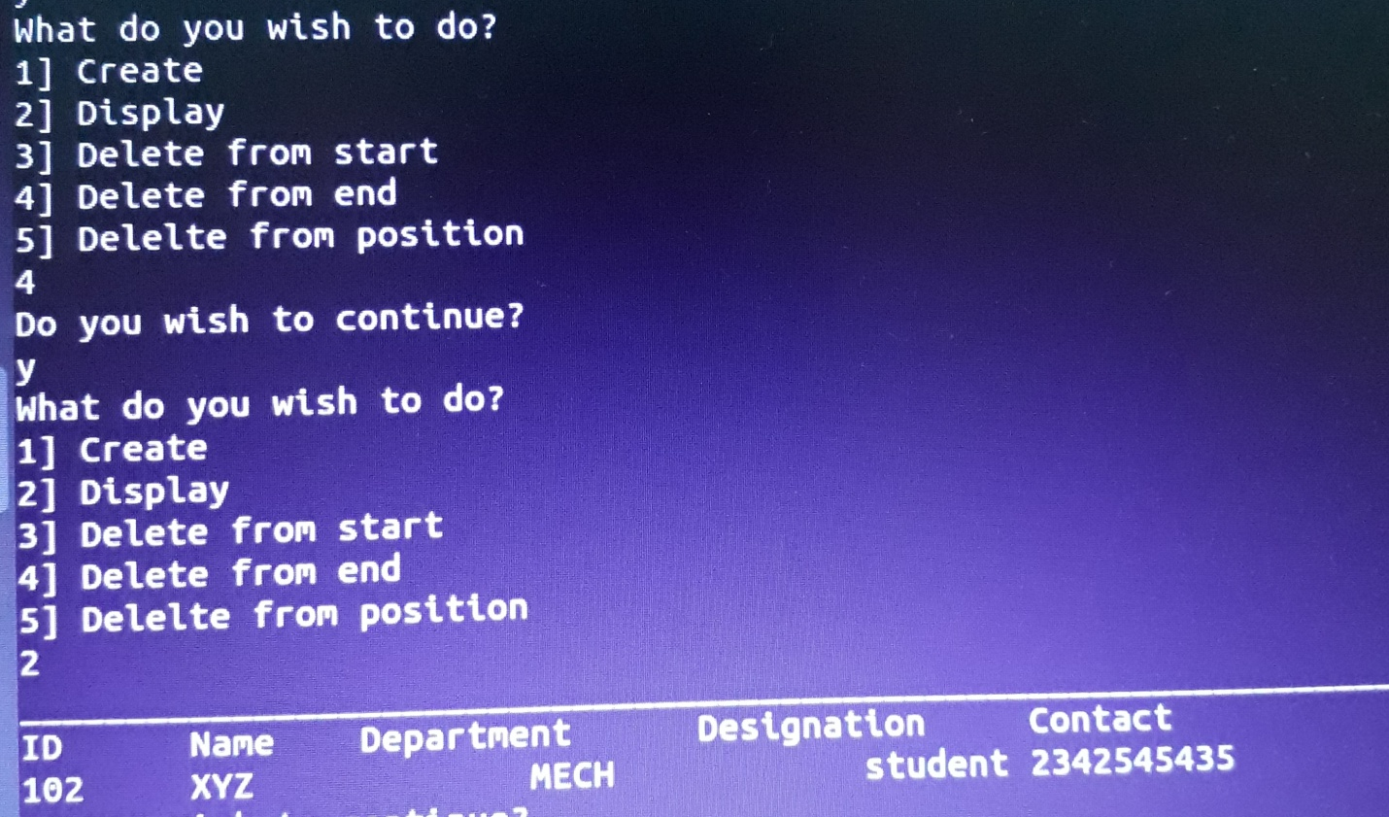

Q6 Design, Develop and Implement a Program in C++ for converting an Infix Expression to Postfix

Expression. Program should support for both parenthesized and free parenthesized expressions with

the operators: +, -, *, /, %,^ and alphanumeric operands.

#include <iostream>

using namespace std;

struct s

{

char stack[20];

int top=-1;

}st;

void push(char ch)

{

st.top++;

st.stack[st.top]=ch;

}

char pop()

{

char ch;

ch=st.stack[st.top];

st.top--;

return ch;

}

int main()

{

char infix[20],postfix[20],c;

int i=0,p=-1;

cout<<"Enter infix expression: ";

cin>>infix;

while(infix[i]!='\0')

{

switch(infix[i])

{

case '+':

case '-':

while(st.top!=-1)

{

if(st.stack[st.top]=='(')

break;

p++;

postfix[p]=pop();

}

push(infix[i]);

break;

case '*':

case '/':

while(st.top!=-1)

{

if(st.stack[st.top]=='('|| st.stack[st.top]=='+' || st.stack[st.top]=='-')

break;

p++;

postfix[p]=pop();

}

push(infix[i]);

break;

case '^':

push(infix[i]);

break;

case '(':

push(infix[i]);

break;

case ')':

while(st.stack[st.top]!='(')

{

p++;

postfix[p]=pop();

}

pop();

break;

default:

p++;

postfix[p]=infix[i];

}

i++;

}

while(st.top!=-1)

{

p++;

postfix[p]=pop();

}

p++;

postfix[p]='\0';

cout<<"\nPostfix: "<<postfix<<endl;

}

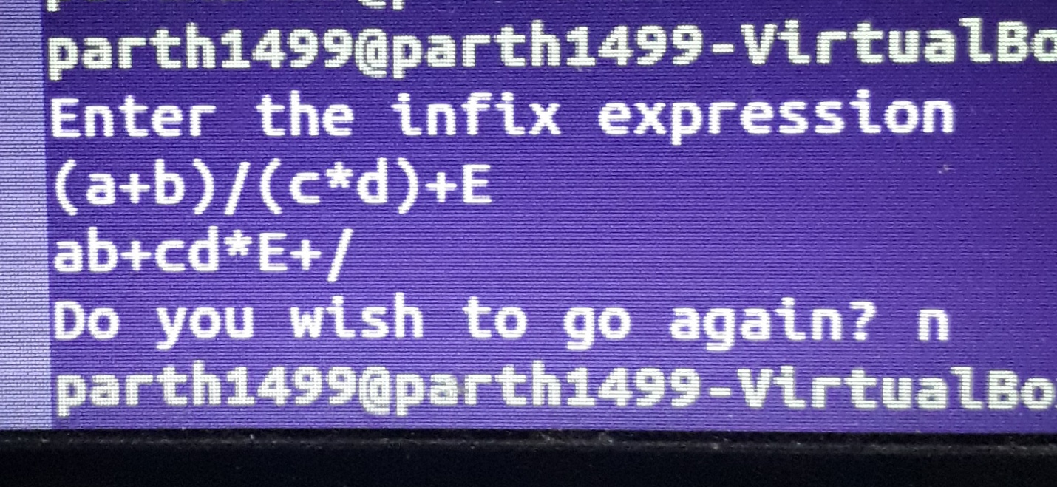

Q7 Pizza parlor accepting maximum M orders. Orders are served in first come first served basis. Order

once placed cannot be cancelled. Write C++ program to simulate the system using circular queue

using array.

#include<iostream>

using namespace std;

int dequeue();

void enqueue();

int queueEmpty();

int queueFull();

void displayOrders();

const int M=5;

static int order=1;

struct pizzaOrder

{

char custName[20];

int orderNo;

};

struct queue

{

int front=-1;

int rear=-1;

struct pizzaOrder order[M];

};

queue st;

int main()

{

int ch;

int status=0;

do{

cout<<"\n\n*****Menu*****\n";

cout<<"1. Take Order.\n";

cout<<"2. Complete an Order.\n";

cout<<"3. View Orders.\n";

cout<<"4. Exit.\n";

cout<<"Enter your choice: ";

cin>>ch;

switch(ch)

{

case 1:

enqueue();

displayOrders();

break;

case 2:

dequeue();

displayOrders();

break;

case 3:

displayOrders();

break;

case 4:

status=1;

break;

}

}while(status!=1);

}

int dequeue()

{

int no;

if(!queueEmpty())

{

no=st.order[st.front].orderNo;

if(st.front==st.rear)

st.front=-1,st.rear=-1;

else

st.front=(st.front+1)%M;

return no;

}

}

void enqueue()

{

if(queueFull())

{

cout<<"\nMaximum order received.....";

return;

}

if(queueEmpty())

st.front=0;

st.rear=(st.rear+1)%M;

st.order[st.rear].orderNo=order++;

cout<<"Enter customer Name: ";

cin>>st.order[st.rear].custName;

}

int queueEmpty()

{

return (st.front==-1)?1:0;

}

int queueFull()

{

return ((st.front==st.rear+1)||(st.front==0 && st.rear==M-1))?1:0;

}

void displayOrders()

{

cout<<"\n|******************************PIZZA ORDERS******************************|\n";

if(queueEmpty())

{

cout<<"\nNo more orders left.....\n";

return;

}

int i;

for(i=st.front;i!=st.rear;i=(i+1)%M)

{

cout<<"\n---------------------------------------------------------";

cout<<"\nOrder No.: "<<st.order[i].orderNo<<"\tCustomer Name: "<<st.order[i].custName;

cout<<"\n---------------------------------------------------------";

}

cout<<"\n---------------------------------------------------------";

cout<<"\nOrder No.: "<<st.order[i].orderNo<<"\tCustomer Name: "<<st.order[i].custName;

cout<<"\n---------------------------------------------------------";

}

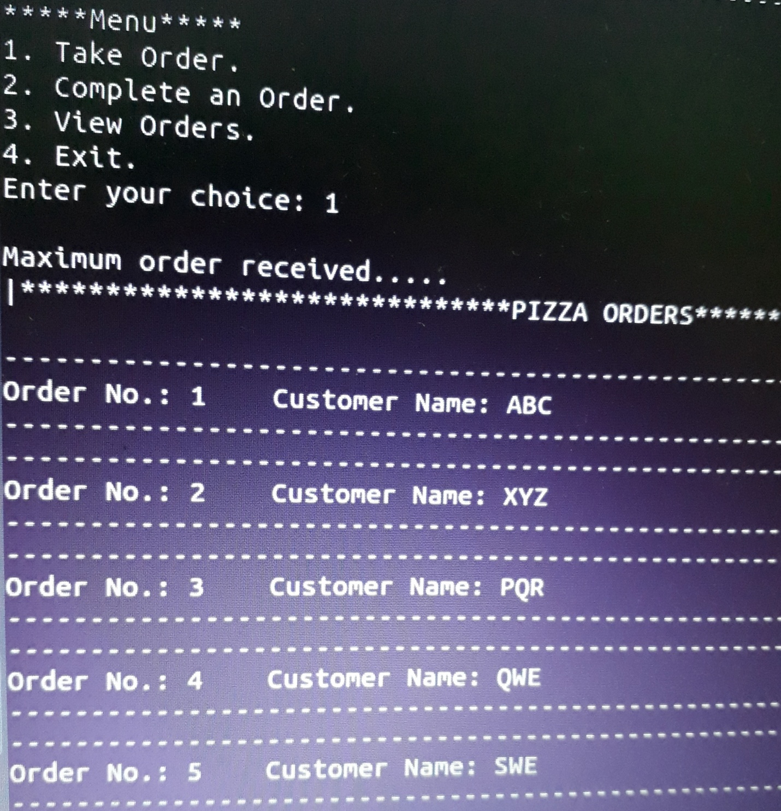

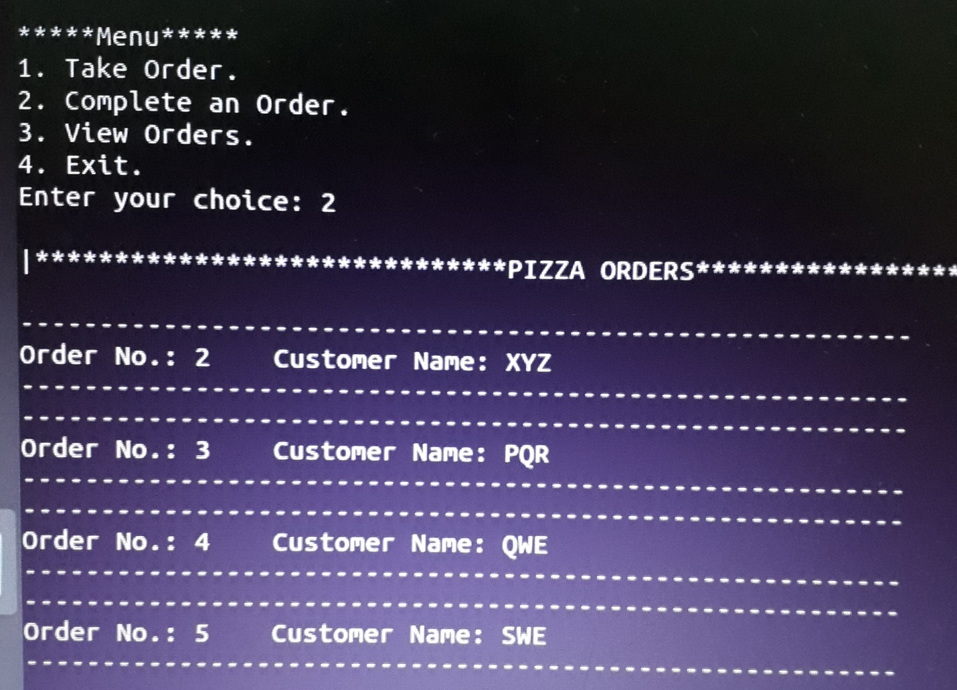

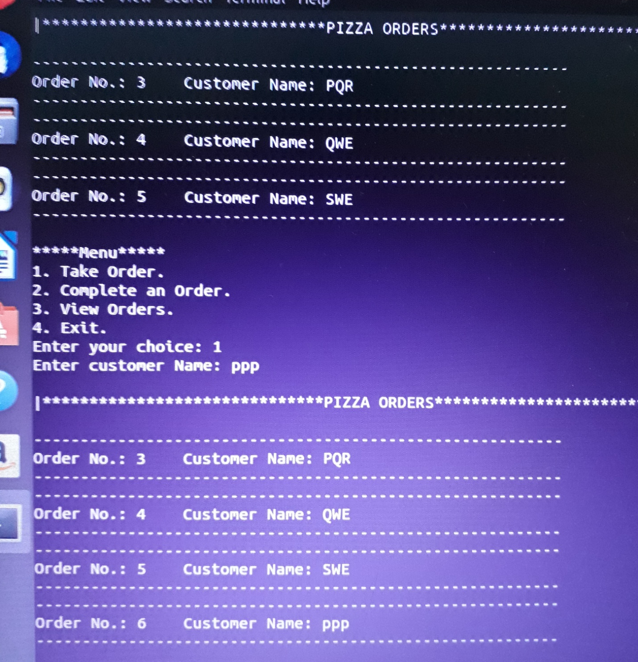

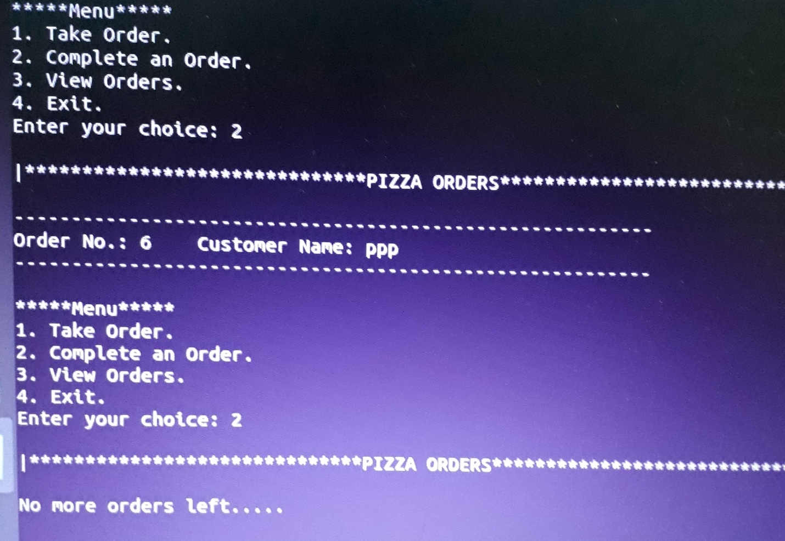

Q9 Write C++ program to store names and mobile numbers of your friends in sorted order on names. a)

Search your friend from list using binary search (recursive and non recursive)

1. #include<iostream>

#include<stdlib.h>

using namespace std;

struct friends

{

char name[20];

long long int ph;

int roll;

};

int main()

{

int num;

cout<<"\n enter the number of friends : ";

cin>>num;

friends obj[num];

cout<<"\n enter the name, phone number and roll number of "<<num<<" friends : \n";

for(int i=0;i<num;i++)

{

cout<<i+1<<" name : "; cin>>obj[i].name;

cout<<i+1<<" phone number : "; cin>>obj[i].ph;

cout<<i+1<<" roll number : "; cin>>obj[i].roll;

}

int r;

cout<<"\n\n enter the roll number you want to search : ";

cin>>r;

int front=0,rear=num-1,mid;

mid=(front+rear)/2;

while(front<=rear)

{

if(obj[mid].roll<r)

{

front=mid+1;

}

else if(obj[mid].roll==r)

{

cout<<"\n"<<r<<" found at "<<mid+1<<"position"<<endl;

cout<<"\n\t details of searched friend are as follows :";

cout<<"\n\t name : "<<obj[mid].name;

cout<<"\n\t phone number : "<<obj[mid].ph;

cout<<"\n\t roll number : "<<obj[mid].roll<<endl;

exit(0);

}

else if(obj[mid].roll>r)

{

rear=mid-1;

}

mid=(front+rear)/2;

}

cout<<"\n data not found ";

return 0;

}

1. #include<iostream>

#include<stdlib.h>

using namespace std;

struct friends

{

char name[10][20];

long long int ph[10];

int roll[10];

}obj;

void search(char name[][20],long long int ph[],int roll[],int

r,int front,int rear)

{

int mid;

while(rear>=1)

{

mid=(front+rear)/2;

if(roll[mid]<r)

{

search(name,ph,roll,r,mid+1,rear);

}

else if(roll[mid]==r)

{

cout<<"\n"<<r<<" found at "<<mid+1<<"position"<<endl;

cout<<"\n\t details of searched friend are as follows :";

cout<<"\n\t name : "<<name[mid];

cout<<"\n\t phone number : "<<ph[mid];

cout<<"\n\t roll number : "<<roll[mid]<<endl;

exit(0);

}

else if(roll[mid]>r)

{

search(name,ph,roll,r,front,mid-1);

}

}

cout<<"\n data not found ";

}

int main()

{

int num;

cout<<"\n enter the number of friends : ";

cin>>num;

cout<<"\n enter the name, phone number and roll number of "<<num<<" friends : \n";

for(int i=0;i<num;i++)

{

cout<<i+1<<" name : ";

cin>>obj.name[i];

cout<<i+1<<" phone number : ";

cin>>obj.ph[i];

cout<<i+1<<" roll number : ";

cin>>obj.roll[i];

}

int r;

cout<<"\n\n enter the roll number you want to search : ";

cin>>r;

search(obj.name,obj.ph,obj.roll,r,0,num-1);

return 0;

}

